Data Analytics Capstone

Finance, Credit Risk Modeling

Final Report Draft

Laxmikant Deshpande

Walsh College

QM640: Data Analytics Capstone

Keya Choudhary Ganguly

3rd Term

10 November 2026

Contents
Introduction 4
Background and Context 4
Problem Statement 4
Purpose of the Study 5
Github Repo details 6
Abstract 7
Research Questions 8
Research Question 1 (RQ1) – Comparative Performance: 8
Research Question 2 (RQ2) – Feature Ranking & Interpretability: 9
Research Question 3 (RQ3) – Threshold & Non-Linear Effects: 10
Research Question 4 (RQ4) – Fairness or Bias: 11
Contributions and Expected Value 12
Practical Contribution 12
Technical Contribution 12
Value to Stakeholders and Target Users 12
Literature Review 13
Literature Review Approach 13
Literature Relevance Matrix 13
Comparative Performance of Machine Learning Models (RQ1) 15
Feature Importance and Interpretability (RQ2) 15
Threshold Effects and Nonlinear Relationships (RQ3) 15
Fairness and Bias in Credit Risk Modelling (RQ4) 16
Research Gap 16
Data Preparation and Feature Engineering 17
Materials and Methods 18
Dataset Description 18
Inclusion and Exclusion Criteria 18
Exploratory Data Analysis (EDA) 19
Research Hypotheses 22
Sample Size Justification 23
Statistical Methods 23
Hypothesis Testing, Interpretation and Model Justification 25
Experimental Design and Original Work 26
Architecture Diagram / Workflow 28
Workflow Components 29
Data Ingestion 29
Data Preprocessing 29
Exploratory Data Analysis (EDA) 29
Feature Engineering 29
Model Development 30
Model Evaluation 30
Deployment (Future Implementation) 30
Tools and Technologies 30
Results 31
Model Performance 31
Visual Evidence 32
Results by Research Question 35
RQ1: Comparative Performance of Machine Learning Models 35
RQ2: Identification of Key Predictors of Default Risk 35
RQ3: Threshold Effects and Nonlinear Relationships 35
RQ4: Fairness Assessment and Bias Mitigation 35
Overall Interpretation 36
Practical Significance 36
Implementation and User Benefit 36
Deployment Approach 36
System Integration 36
User Interaction 37
Benefits to Users 37
Example Use Case 37
Limitations and Further Improvements 38
Limitations 38
Impact of Limitations 38
Future Improvements 38
Future Scope 38
Appendix 39
Appendix A: Model Development and Evaluation Code 39
39
Appendix B: Explainability and Fairness Analysis Code 39
Appendix C: Data Dictionary 40
References 41

Introduction

Background and Context
Credit risk assessment is a critical activity within banking and consumer lending, as it enables financial institutions to evaluate the likelihood that borrowers will repay their financial obligations. Accurate prediction of credit default helps reduce financial losses, improve portfolio quality, support effective risk management, and ensure regulatory compliance. As lending volumes continue to increase, organizations require reliable analytical approaches to identify high-risk customers before defaults occur.
Traditionally, credit risk has been evaluated using statistical techniques such as Logistic Regression due to their simplicity and interpretability. However, advances in machine learning have created opportunities to improve predictive performance by capturing complex nonlinear relationships within borrower behaviour. At the same time, growing concerns regarding model transparency and fairness have increased the importance of explainable and responsible artificial intelligence. Consequently, modern credit risk systems must balance predictive accuracy, interpretability, and fairness to support effective and equitable lending decisions.

Problem Statement
The objective of this study is to predict credit default risk (Y) for individual credit card customers using demographic characteristics, repayment history variables, billing information, payment behaviour variables, and engineered financial indicators (X) derived from the Taiwan credit card default dataset. Model performance is evaluated using Accuracy, Precision, Recall, F1 Score, Area Under the Receiver Operating Characteristic Curve (AUC), Balanced Accuracy, and Brier Score.
The study evaluates whether advanced machine learning techniques can improve predictive performance, interpretability, threshold identification, and fairness compared with traditional statistical approaches. The target variable, CreditRisk (labelled ‘default payment next month’ in the original dataset), indicates whether a customer defaulted on the payment due in the month following the final observed billing period.
The analysis utilizes demographic, financial, repayment-history, billing, payment, and engineered behavioural variables as predictors of default risk. The predictor variables are grouped as follows:
- Demographic Variables (4): SEX, AGE, EDUCATION, MARRIAGE.
- Credit Limit Variable (1): LIMIT_BAL.
- Repayment Status Variables (6): PAY_0, PAY_2, PAY_3, PAY_4, PAY_5, and PAY_6.
- Billing Variables (6): BILL_AMT1 to BILL_AMT6.
- Payment Variables (6): PAY_AMT1 to PAY_AMT6.
- Engineered Variables (8): TOTAL_BILL, TOTAL_PAY, AVG_UTIL_RATIO, AVG_PAY_RATIO, BILL_TREND, PAY_TREND, MISSED_PAYMENTS, and OVERPAYMENTS.
The customer identifier (ID) was excluded from modelling because it contains no predictive information. Model performance was evaluated using Accuracy, Precision, Recall, F1 Score, Area Under the Receiver Operating Characteristic Curve (AUC), Balanced Accuracy, and Brier Score. Beyond predictive accuracy, the study also investigates model explainability, nonlinear borrower-risk behaviour, and fairness-aware machine learning techniques, reflecting the increasing importance of transparent and responsible artificial intelligence in modern credit risk assessment.

Purpose of the Study
The purpose of this study is to design, implement, and evaluate machine learning techniques for estimating the Probability of Default (PD) using credit card customer data. Unlike conventional classification approaches that focus solely on identifying defaulters, this research seeks to develop predictive models that accurately estimate default risk while maintaining transparency, fairness, and practical relevance to credit risk management (Aboulmaouda et al., 2026; Alcarva, 2026).
The study pursues four primary objectives. These objectives are informed by prior research emphasizing the importance of predictive performance, interpretability, threshold detection, and fairness in modern credit risk assessment systems (Noriega et al., 2023; Vieira et al., 2025).
- To compare the predictive performance of traditional statistical models and advanced machine learning models for estimating the Probability of Default.
- To identify and explain the most influential drivers of default risk using statistical analysis, machine learning feature importance techniques, and explainable artificial intelligence (XAI) methods.
- To detect and evaluate threshold effects and nonlinear relationships within borrower characteristics, repayment behaviour, and credit utilisation patterns.
- To assess potential demographic bias and evaluate fairness-aware machine learning techniques that improve equity while maintaining predictive performance.

Github Repo details
All data, code, results and documentation are in the GitHub repository: https://github.com/tigerlaxmikant/MS_Data_Analytics_Capstone_Project.
File locations and execution steps are given under GitHub Data Availability Statement
Repository Contents:
- Complete project notebook
- Data preprocessing code
- Feature engineering code
- Model development and evaluation code
- Explainability analysis (SHAP and LIME)
- Fairness assessment and mitigation code
- Generated tables and figures
- Supporting project documentation


Abstract
Credit default prediction is an important problem in financial risk management because inaccurate lending decisions can increase financial losses and credit exposure. This study develops and evaluates machine learning models for predicting the Probability of Default (PD) of credit-card customers using demographic, financial, repayment-history, and engineered behavioural variables.
The analysis utilised the Taiwan Default of Credit Card Clients dataset from the UCI Machine Learning Repository, containing 30,000 customer records. Data preprocessing included categorical cleaning, feature engineering, robust scaling, and stratified train-test splitting. Logistic Regression, Decision Tree, Random Forest, XGBoost, and Weighted XGBoost were evaluated using Accuracy, Precision, Recall, F1 Score, Area Under the ROC Curve (AUC), Balanced Accuracy, and Brier Score. Additional analyses included SHAP, LIME, threshold detection, and fairness assessment using AIF360.
XGBoost achieved the strongest baseline performance with an AUC of 0.7800 and F1 Score of 0.4665, while Weighted XGBoost achieved the highest Recall (61.68%) and F1 Score (0.5406). Repayment-history variables, particularly PAY_0 and PAY_2, emerged as the strongest predictors of default risk. Threshold analysis identified repayment delays greater than one month as the most influential borrower-risk breakpoint. Fairness-aware machine learning methods reduced demographic disparities while maintaining predictive performance.
The proposed framework can be deployed as a credit-risk decision-support system to assist financial institutions in making more accurate, transparent, and equitable lending decisions.

Research Questions

Research Question 1 (RQ1) – Comparative Performance:

Whether machine learning models such as decision trees and ensemble methods outperform the traditional statistical baseline model (logistic regression) in predicting probability of default (PD).
- Ho (Null Hypothesis): Advanced ML models do not significantly outperform logistic regression in PD prediction.

- Ha (Alternative Hypothesis): At least one advanced ML model achieves an AUC at least 0.05 higher than logistic regression on the held-out test set (ΔAUC ≥ 0.05). Recall, F1-score, Balanced Accuracy and Brier Score are reported as secondary measures.

Methodology:
- Preprocess dataset (cleaning, encoding categorical variables, handling imbalance).
- Train Logistic Regression as the baseline model.
- Decision Tree, Random Forest, XGBoost, and Weighted XGBoost

- Apply cross-validation to ensure robustness of results.
- Evaluate each model using:
  - Accuracy
  - Precision
  - Recall
  - F1-score
  - AUC (Area Under ROC Curve)
  - Brier Score (probability calibration)
- Compare performance across models to determine whether advanced ML methods outperform the baseline.

Research Question 2 (RQ2) – Feature Ranking & Interpretability:

Which predictors (e.g., Credit Limit, Repayment History, Bill Amounts, Payment Amounts, Demographic Characteristics, and Engineered Features) rank highest in importance for credit risk prediction, and how consistent are these rankings across Random Forest, XGBoost, SHAP, and other interpretability techniques?

- Ho (Null Hypothesis): Predictor importance rankings are inconsistent across statistical analysis, machine learning models, and explainability methods, and therefore do not identify stable drivers of default risk.
- Ha (Alternative Hypothesis): Repayment-history and behavioural variables consistently emerge as the strongest predictors of Probability of Default across statistical analysis, machine learning models, and explainable artificial intelligence techniques.
Methodology:
- Conduct statistical analyses, including correlation analysis and chi-square tests, to identify initial predictor relevance.

- Extract feature importance scores from Random Forest and XGBoost models.
- Apply Permutation Importance to evaluate the impact of each predictor on model performance.
- Use SHAP to explain both global and local contributions of predictors to default risk.
- Apply LIME to explain individual borrower predictions.
- Compare predictor rankings across all analytical methods to identify stable and robust drivers of default risk.
- Assess the relative influence of demographic variables and evaluate potential sources of bias in feature importance rankings.

Research Question 3 (RQ3) – Threshold & Non-Linear Effects:

Are there critical thresholds or non-linear interactions among credit limit, bill amounts, and payment history that disproportionately increase the probability of default (PD), and can advanced machine learning models detect these breakpoints more effectively than traditional regression?
H₀ (Null Hypothesis):
Threshold effects and nonlinear relationships do not significantly alter default risk predictions compared with linear modelling approaches.
Hₐ (Alternative Hypothesis):
Threshold effects and nonlinear relationships significantly increase default risk, with at least one identified threshold producing an increase in the default rate of 15 percentage points or more.
Methodology:
- Fit Linear and Polynomial Logistic Regression models to evaluate the presence of nonlinear relationships.
- Use XGBoost as the primary nonlinear modelling framework based on the superior predictive performance identified in RQ1.
- Generate Partial Dependence Plots (PDPs) to visualise the relationship between key predictors and default risk.
- Apply SHAP dependence plots to identify threshold points where default risk increases sharply.
- Examine key predictors identified in RQ2, including PAY_0, PAY_2, MISSED_PAYMENTS, AVG_UTIL_RATIO, and LIMIT_BAL.
- Validate threshold effects across multiple analytical approaches, including feature-importance analysis, PDPs, and SHAP dependence plots.
- Quantify predictive lift by comparing default rates above and below identified thresholds.
- Evaluate whether detected threshold effects satisfy the predefined hypothesis criterion of a minimum 15-percentage-point increase in default risk.

Research Question 4 (RQ4) – Fairness or Bias:

Do demographic predictors (Gender, Age, Education, Martial status) introduce bias in credit risk predictions, and can fairness metrics (Demographic Parity, Equal Opportunity) detect and mitigate this bias?
- Ho (Null Hypothesis): Demographic variables do not introduce significant bias in probability of default predictions.
- Ha (Alternative Hypothesis): Demographic variables introduce measurable bias, which can be mitigated using fairness-aware machine learning without more than a 5% loss in accuracy.

Methodology:
- Train models with demographic predictors (Gender, Age, Education, Martial status) included and excluded.
- Apply fairness metrics such as:
- Demographic Parity Difference
- Equal Opportunity Difference
- Disparate Impact Ratio

- Compare fairness results across models to detect bias in PD estimates.
- Implement bias mitigation strategies:
- Re-sampling
- Re-weighting
- Adversarial debiasing

- Re-evaluate models after mitigation to measure improvements in fairness.
- Assess trade-offs between fairness gains and predictive accuracy.
- Document whether fairness-aware ML can reduce bias without significantly harming performance.

Contributions and Expected Value

Practical Contribution
This study provides a comprehensive credit risk prediction framework that supports the identification of borrowers with elevated default risk using both traditional statistical methods and advanced machine learning techniques. By integrating predictive modelling, explainable artificial intelligence, threshold analysis, and fairness assessment, the study offers actionable insights that can support lending decisions, portfolio monitoring, and risk management activities within financial institutions. The findings enable risk managers to better understand borrower behaviour, identify high-risk accounts earlier, and implement targeted risk-mitigation strategies.

Technical Contribution
The study contributes to the credit risk analytics literature by systematically comparing Logistic Regression, Decision Tree, Random Forest, XGBoost, and class-imbalance handling techniques within a unified modelling framework. In addition to predictive modelling, the study integrates multiple explainability approaches, including Feature Importance Analysis, Permutation Importance, SHAP, and LIME, to provide both global and local model interpretability. Furthermore, the research investigates nonlinear borrower-risk behaviour through Partial Dependence Plots, SHAP Dependence Analysis, and Predictive Lift Analysis, while evaluating fairness-aware machine learning approaches such as Reweighing and Adversarial Debiasing.

Value to Stakeholders and Target Users
The proposed framework provides value to banks, credit card issuers, lending institutions, risk analysts, compliance professionals, and data science practitioners. The study demonstrates how machine learning can improve default prediction while maintaining interpretability and fairness. The identification of critical repayment-behaviour thresholds, key drivers of default risk, and fairness-performance trade-offs can support more transparent, responsible, and effective credit decision-making processes. Ultimately, the framework helps organizations balance predictive accuracy, regulatory expectations, and equitable treatment of borrowers.

Literature Review

Literature Review Approach
The literature review was conducted using peer-reviewed journal articles and conference papers obtained from Google Scholar, IEEE Xplore, SpringerLink, and Elsevier ScienceDirect. Keywords included credit risk modelling, credit scoring, logistic regression, random forest, XGBoost, SHAP, fairness in machine learning, interpretability, and threshold effects.
Sources were selected based on their relevance to credit default prediction, explainable artificial intelligence, threshold detection, and fairness in credit risk assessment. The reviewed studies provide the theoretical and methodological foundation for Research Questions 1–4.

Literature Relevance Matrix

Table 1: Literature relevance matrix
Author (Year) | Domain/Context | Dataset/Setting | Method(s) | Key Findings | How it Supports RQ(s) / Project Decisions
Lessmann et al. (2015) | Credit scoring benchmarking | Multiple credit-scoring datasets | Comparative evaluation of 41 classifiers | Ensemble methods consistently outperformed Logistic Regression | Supports RQ1 by justifying comparison between traditional statistical models and advanced machine learning models
Crook et al. (2022) | Consumer credit risk assessment | UK banking data | Logistic Regression and Neural Networks | Neural networks improved predictive performance but reduced interpretability | Supports RQ1 and RQ2 by highlighting the performance-interpretability trade-off
Zhang et al. (2021) | Credit default prediction | Chinese lending dataset | XGBoost and SHAP | Repayment history and billing variables were dominant predictors | Supports RQ2 by motivating feature importance and explainability analysis
Bastani et al. (2019) | Interpretable machine learning | Credit-scoring applications | Decision Trees and rule extraction | Transparent decision rules improved stakeholder trust and model understanding | Supports RQ2 and RQ3 through model interpretability and threshold identification
Lou et al. (2013) | Nonlinear modelling and threshold detection | Loan repayment data | Partial Dependence Plots (PDPs) | Identified nonlinear breakpoints and threshold effects in default risk | Directly supports RQ3 and motivates PDP-based threshold analysis
Mathibela and Maposa (2026) | Credit default prediction | German Credit Dataset | Logistic Regression, Random Forest, XGBoost, SHAP | Ensemble models achieved superior predictive performance | Supports RQ1 and RQ2 by validating ensemble learning and explainable AI techniques
Springer (2026) | Fairness in credit scoring | Lending Club dataset | Fairness–accuracy trade-off analysis | Fairness improvements may require performance trade-offs | Supports RQ4 and fairness-performance evaluation
Barocas et al. (2019) | Fairness in machine learning | Financial-services applications | Demographic Parity and Equal Opportunity metrics | Demonstrated how demographic variables can produce biased outcomes | Provides theoretical foundation for RQ4 fairness assessment
Hand and Henley (1997) | Credit scoring foundations | UK credit-scoring applications | Logistic Regression | Established Logistic Regression as a robust and interpretable baseline | Justifies the baseline model used in RQ1
Ribeiro et al. (2016) | Machine learning interpretability | General machine learning applications | LIME | Local explanations improved transparency and trust in model predictions | Supports RQ2 and responsible AI objectives in RQ4

Comparative Performance of Machine Learning Models (RQ1)
The literature consistently shows that advanced machine learning algorithms outperform traditional statistical approaches in credit risk prediction. Lessmann et al. (2015) reported that ensemble methods such as Random Forest and Gradient Boosting achieved higher predictive performance than Logistic Regression across multiple credit-scoring datasets. Similarly, Mathibela and Maposa (2026) found that ensemble models produced superior predictive accuracy and discrimination capability.
Despite these advantages, Logistic Regression remains widely used because of its interpretability and regulatory acceptance (Hand & Henley, 1997). Crook et al. (2022) further highlighted the trade-off between predictive performance and model transparency. These findings support the comparison of traditional and advanced machine learning models undertaken in this study.

Feature Importance and Interpretability (RQ2)
Model interpretability has become increasingly important in credit risk assessment. Zhang et al. (2021) demonstrated that SHAP effectively identifies the most influential predictors of default risk, particularly repayment-history and billing-related variables. Ribeiro et al. (2016) showed that LIME improves transparency by providing explanations for individual predictions.
Similarly, Bastani et al. (2019) found that interpretable decision rules improve stakeholder trust and understanding. Collectively, these studies support the use of multiple explainability techniques to identify consistent drivers of credit default risk.

Threshold Effects and Nonlinear Relationships (RQ3)
Previous research indicates that borrower risk often exhibits nonlinear behaviour. Lou et al. (2013) demonstrated that Partial Dependence Plots can reveal threshold effects and critical breakpoints that are not easily captured by linear models. Such threshold effects are particularly relevant in credit risk assessment, where repayment delays and financial stress can disproportionately increase default risk.
Tree-based machine learning models naturally capture nonlinear relationships and interactions, making them suitable for threshold detection. These findings provide the foundation for investigating nonlinear borrower-risk behaviour in the present study.

Fairness and Bias in Credit Risk Modelling (RQ4)
The increasing use of machine learning in lending has raised concerns regarding fairness and demographic bias. Barocas et al. (2019) demonstrated that predictive models may unintentionally generate disparate outcomes across demographic groups, highlighting the importance of fairness assessment in high-stakes decision-making.
Springer (2026) further showed that improving fairness may involve trade-offs with predictive performance. These studies support the use of fairness metrics and bias-mitigation techniques to evaluate whether equitable outcomes can be achieved without substantially reducing model effectiveness.

Research Gap
Despite significant advances in credit risk modelling, several gaps remain in the literature. Many studies focus primarily on predictive performance while giving limited attention to interpretability, threshold effects, and fairness considerations. In addition, feature-importance studies often rely on a single explainability technique, and threshold effects are rarely validated using multiple complementary approaches.
Furthermore, relatively few studies evaluate predictive performance, explainability, nonlinear relationships, and fairness within a single integrated framework. The present study addresses these gaps by combining machine learning, explainable AI, threshold analysis, and fairness assessment within a unified probability-of-default modelling framework.

Data Preparation and Feature Engineering

Data preprocessing was performed prior to model development to improve data quality, ensure consistency, and support robust predictive modelling.
All variables were converted to their appropriate numeric formats. Categorical variables were cleaned and recoded to remove invalid or infrequent categories. Specifically, EDUCATION values of 0, 5, and 6 were grouped into an "Other" category, while MARRIAGE values coded as 0 were recategorized as "Other". The SEX variable was converted into a binary representation to facilitate model implementation.
A data-quality assessment confirmed that the dataset contained no missing values and no duplicate customer records after preprocessing. Outlier analysis was conducted using Z-score methodology across financial variables including credit limits, bill amounts, and payment amounts. Because financial data naturally contains extreme values, observations were retained and handled through robust scaling rather than deletion to preserve potentially important risk information.
To improve predictive performance and better capture borrower behaviour, eight engineered features were created:
- TOTAL_BILL: Total bill amount across six months.
- TOTAL_PAY: Total payment amount across six months.
- AVG_UTIL_RATIO: Average credit utilization ratio.
- AVG_PAY_RATIO: Average payment-to-bill ratio.
- BILL_TREND: Change in bill amounts over time.
- PAY_TREND: Change in payment amounts over time.
- MISSED_PAYMENTS: Number of months with no recorded payment.
- OVERPAYMENTS: Number of months where payment exceeded the billed amount.

These engineered variables were designed to capture repayment behaviour, spending patterns, utilization behaviour, and financial stress indicators that may not be fully represented by the original variables alone.
Continuous variables were scaled using the RobustScaler algorithm. Robust scaling was selected because it is less sensitive to extreme observations than standard normalization techniques and is therefore particularly suitable for financial datasets containing outliers.
Finally, the dataset was divided into training and testing subsets using a 70:30 stratified split. Stratification ensured that the original default-rate distribution was preserved across both datasets, thereby reducing sampling bias and improving evaluation reliability.

Materials and Methods

Dataset Description
This study utilised the Default of Credit Card Clients Dataset obtained from the UCI Machine Learning Repository. The dataset contains information on 30,000 credit card clients in Taiwan and includes demographic characteristics, credit information, repayment histories, bill statements, payment records, and default status. The target variable, default.payment.next.month, indicates whether a customer defaulted on their credit card payment in the subsequent month.
The dataset comprises 24 predictor variables and one binary target variable. Predictor variables include demographic attributes such as age, gender, education, and marital status, as well as financial attributes including credit limit, historical repayment status, bill amounts, and previous payment amounts.
A complete data dictionary is provided in Appendix A.

Inclusion and Exclusion Criteria
Inclusion Criteria
The study included all customer records that contained:
- Valid demographic information (SEX, AGE, EDUCATION, and MARRIAGE).
- Repayment status history variables (PAY_0 to PAY_6).
- Billing statement variables (BILL_AMT1 to BILL_AMT6).
- Payment history variables (PAY_AMT1 to PAY_AMT6).
- Valid target labels indicating default or non-default status.
Exclusion Criteria
The following exclusions were applied:
- The customer identification variable (ID) was removed because it does not contain predictive information.
- Invalid education categories (0, 5, and 6) were consolidated into the “Other” category.
- Invalid marriage category (0) was consolidated into the “Other” category.
- Duplicate header rows introduced during dataset import were removed.
No observations were removed due to missing values or duplicate records because the dataset contained complete customer records.

Exploratory Data Analysis (EDA)

Figure 1: Class Distribution of Credit Risk
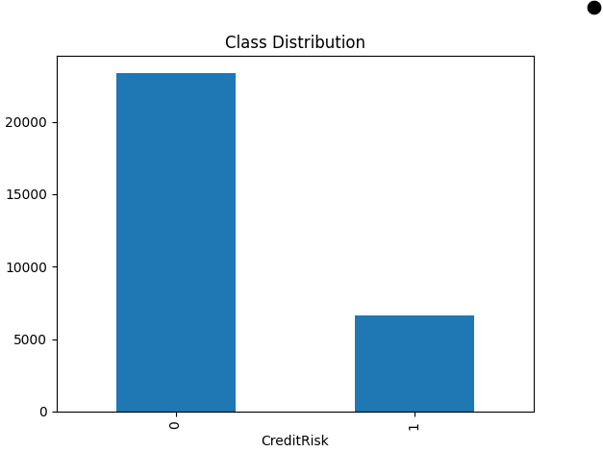
The age distribution indicated that most customers were concentrated between approximately 25 and 45 years of age, with fewer observations at older ages. The uneven age distribution justified evaluating fairness metrics across age groups as part of RQ4.

Figure 2: ROC Curve
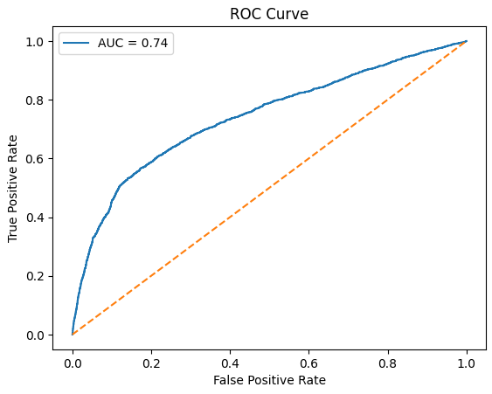
Figure 3: Age Distribution
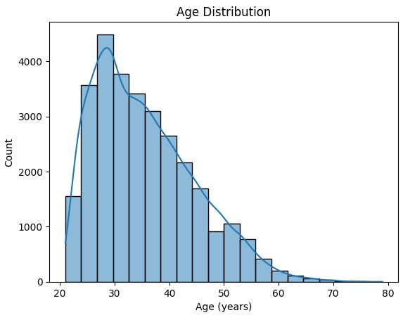
The age distribution indicated that most customers were concentrated between approximately 25 and 45 years of age, with fewer observations at older ages. The uneven age distribution justified evaluating fairness metrics across age groups as part of RQ4.

Figure 4: Credit Limit Distribution
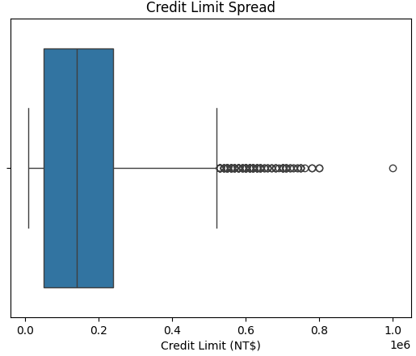
The credit-limit distribution exhibited substantial variability and several extreme values. These outliers are typical in financial datasets and represent genuine customer behaviours. Consequently, outliers were retained and handled using RobustScaler rather than removed from the dataset.

Figure 5: Correlation Heatmap
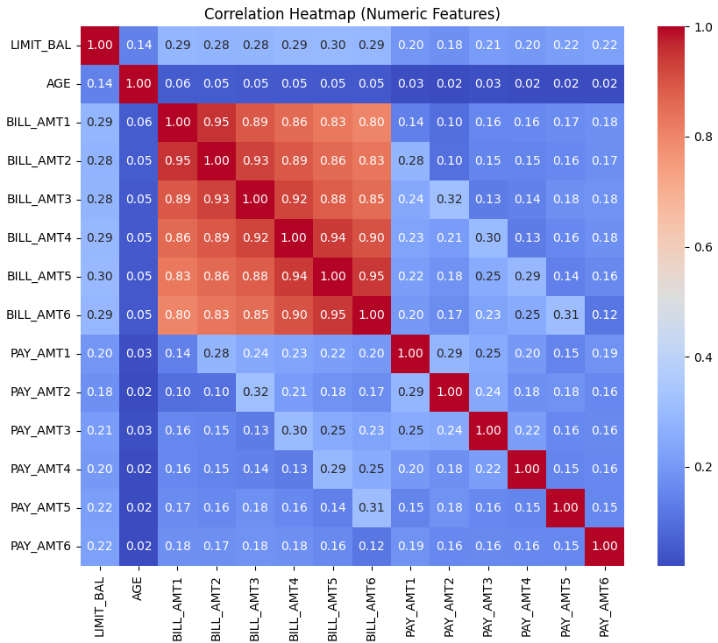
The correlation analysis revealed strong relationships among monthly bill amount variables and moderate relationships among payment variables. Several repayment-history variables demonstrated positive associations with default risk. These findings supported the development of engineered features and informed subsequent feature-importance analysis.

EDA Summary
The EDA findings identified three important characteristics of the dataset. First, moderate class imbalance justified the use of imbalance-aware evaluation metrics and mitigation strategies. Second, financial variables contained genuine extreme observations, necessitating robust scaling techniques. Third, repayment-history and behavioural variables exhibited stronger relationships with default risk than demographic variables, suggesting their importance in subsequent modelling and explainability analyses.

Research Hypotheses
Research Question 1 (RQ1)
H₀: Advanced machine learning models do not significantly outperform Logistic Regression in predicting Probability of Default (PD).
Hₐ: At least one advanced machine learning model achieves an AUC at least 0.05 higher than Logistic Regression on the held-out test dataset (ΔAUC ≥ 0.05).

Research Question 2 (RQ2)
H₀: Predictor importance rankings are inconsistent across statistical analysis, machine learning models, and explainability techniques, and therefore do not identify stable drivers of default risk.
Hₐ: Repayment-history and behavioural variables consistently emerge as the strongest predictors of Probability of Default across statistical analysis, machine learning models, and explainable artificial intelligence techniques.

Research Question 3 (RQ3)
H₀: Threshold effects and nonlinear relationships do not significantly alter default-risk predictions compared with linear modelling approaches.
Hₐ: Threshold effects and nonlinear relationships significantly increase default risk, with at least one identified threshold producing an increase in the default rate of 15 percentage points or more.

Research Question 4 (RQ4)
H₀: Demographic variables do not introduce significant bias in Probability of Default predictions.
Hₐ: Demographic variables introduce measurable bias, which can be mitigated using fairness-aware machine learning techniques without more than a 5% reduction in predictive accuracy.

Sample Size Justification
Minimum sample-size requirements were calculated separately for each research question using methods aligned with the corresponding analytical objectives.
Table 2: Sample Sizes
Research Question | Method Used | Required Sample Size
RQ1 | Hanley–McNeil AUC Comparison | 1,304 Customers
RQ2 | Logistic Regression Predictor Test | 554 Customers
RQ3 | Events-Per-Variable (EPV) Analysis | 3,892 Customers
RQ4 | Fairness Group Comparison | 1,752 Customers per Group

The Taiwan Credit Card Default dataset contains 30,000 customer records, including 6,636 default events (22.1%) and 23,364 non-default events (77.9%). Therefore, the available sample substantially exceeds the minimum sample-size requirements for all four research questions. The dataset provides sufficient statistical power for predictive modelling, feature-importance analysis, threshold detection, and fairness assessment.

Statistical Methods
Several statistical, machine learning, explainability, and fairness-analysis techniques were employed to address the four research questions.
Correlation Analysis
Pearson correlation analysis was conducted to examine relationships between numerical variables and identify predictors most strongly associated with default risk. Correlation analysis also assisted in identifying multicollinearity and informed the feature-engineering process.
Chi-Square Test of Independence
Chi-Square tests were applied to categorical demographic variables (SEX, EDUCATION, and MARRIAGE) to evaluate their association with credit default risk. Statistical significance was evaluated at the 5% significance level (α = 0.05).
Decision Rule:
- Reject H₀ if p-value < 0.05
- Fail to reject H₀ if p-value ≥ 0.05
Predictive Modelling
Four supervised learning models were developed and compared:
- Logistic Regression (baseline statistical model)
- Decision Tree
- Random Forest
- XGBoost
In addition, a class-weighted XGBoost model was evaluated to address class imbalance and improve detection of defaulting customers.
Model performance was assessed using:
- Accuracy
- Precision
- Recall
- F1 Score
- Area Under the ROC Curve (AUC)
- Balanced Accuracy
- Brier Score
Cross-Validation
Five-fold Stratified Cross-Validation was performed to evaluate model stability and generalizability. Stratification preserved the original default-rate distribution across validation folds and reduced the likelihood of performance estimates being influenced by a single train-test split.
Explainable Artificial Intelligence (XAI)
To improve model transparency and interpretability, multiple explainability techniques were applied:
- Random Forest Feature Importance
- XGBoost Feature Importance
- Permutation Importance
- SHAP (SHapley Additive Explanations)
- LIME (Local Interpretable Model-Agnostic Explanations)
These methods were used to identify both global and local drivers of default risk and to evaluate the consistency of predictor rankings across analytical approaches.
Threshold and Non-Linear Effect Analysis
Threshold effects and nonlinear relationships were investigated using:
- Polynomial Logistic Regression
- Partial Dependence Plots (PDPs)
- SHAP Dependence Plots
- Predictive Lift Analysis
These techniques were used to identify critical breakpoints where borrower risk increased disproportionately.
Fairness Assessment
Fairness was evaluated across demographic attributes including SEX, AGE, EDUCATION, and MARRIAGE using three commonly adopted fairness metrics:
- Demographic Parity Difference (DPD)
- Equal Opportunity Difference (EOD)
- Disparate Impact Ratio (DIR)
Bias Mitigation Techniques
Three fairness-improvement strategies were evaluated:
- Synthetic Minority Oversampling Technique (SMOTE)
- Reweighing (AIF360)
- Adversarial Debiasing (AIF360)
The effectiveness of each mitigation technique was assessed by comparing fairness improvements against changes in predictive performance.
Hypothesis Evaluation
All statistical hypothesis tests were evaluated at a significance level of α = 0.05. Research hypotheses were accepted or rejected based on statistical evidence, predictive performance, fairness outcomes, and predefined decision criteria established for each research question.

Hypothesis Testing, Interpretation and Model Justification
All statistical hypothesis tests were evaluated at a significance level of α = 0.05. For Chi-Square tests conducted in RQ2, the null hypothesis was rejected when the p-value was less than 0.05. Research hypotheses for RQ1–RQ4 were subsequently evaluated using the predefined decision criteria established for each research question.
The selected analytical techniques were chosen to address the study objectives. Logistic Regression served as the interpretable baseline model, while Decision Tree, Random Forest, and XGBoost were used to capture nonlinear relationships and improve predictive performance. SHAP, LIME, and feature-importance methods were applied to improve model interpretability, while Partial Dependence Plots and SHAP Dependence Plots were used to investigate threshold effects and nonlinear borrower-risk behaviour. Fairness was evaluated using Demographic Parity Difference, Equal Opportunity Difference, and Disparate Impact Ratio, with SMOTE, Reweighing, and Adversarial Debiasing implemented as bias-mitigation strategies.

Experimental Design and Original Work
The study followed a structured machine learning workflow consisting of data preprocessing, feature engineering, predictive modelling, explainability analysis, threshold detection, and fairness assessment.
Data Access and Setup
The dataset was obtained from the UCI Machine Learning Repository and imported into the Google Colab environment using Python. Data manipulation and preprocessing were performed using Pandas and NumPy, while model development and evaluation were conducted using Scikit-learn, XGBoost, SHAP, LIME, and AIF360.
Data Splitting
The dataset was partitioned using a stratified 70:30 train-test split to preserve the original class distribution. This produced 21,000 training observations and 9,000 testing observations. Stratification helped ensure reliable evaluation by maintaining similar proportions of default and non-default customers across both datasets.
Model Development
Four predictive models were developed and compared:
- Logistic Regression
- Decision Tree
- Random Forest
- XGBoost
A class-weighted XGBoost model was additionally evaluated to investigate the impact of class-imbalance handling on predictive performance.
Model Validation
Model stability was assessed using five-fold stratified cross-validation. This approach reduced the likelihood that model performance was dependent on a single train-test split and provided a more reliable estimate of generalisation performance.
Performance Evaluation
Models were evaluated using:
- Accuracy
- Precision
- Recall
- F1 Score
- Area Under the ROC Curve (AUC)
- Balanced Accuracy
- Brier Score
These metrics were selected because the dataset exhibits class imbalance and because credit-risk models require both accurate classification and reliable probability estimation.
Original Contribution
The primary contribution of this study extends beyond predictive modelling. In addition to comparing machine learning algorithms, the study developed eight engineered behavioural features, conducted multi-method explainability analysis using Feature Importance, Permutation Importance, SHAP, and LIME, investigated nonlinear borrower-risk behaviour using Partial Dependence Plots and SHAP Dependence Analysis, and evaluated fairness using Demographic Parity Difference, Equal Opportunity Difference, and Disparate Impact Ratio.
Furthermore, three bias-mitigation strategies—SMOTE, Reweighing, and Adversarial Debiasing—were implemented and compared to identify an appropriate balance between predictive performance and fairness.
Comparison with Current Methods
Traditional credit-scoring systems commonly rely on Logistic Regression because of its simplicity and interpretability. In this study, Logistic Regression was used as the baseline model and compared with Decision Tree, Random Forest, and XGBoost models. The machine learning models demonstrated superior predictive performance, particularly in terms of Recall, F1 Score, Balanced Accuracy, and AUC. XGBoost emerged as the strongest baseline model, while explainability and fairness analyses demonstrated that improved predictive performance can be achieved without sacrificing transparency or fairness. These findings are consistent with recent credit-risk modelling literature that reports advantages of ensemble learning methods over traditional statistical approaches.

Architecture Diagram / Workflow
1. DATA SOURCE
UCI Credit Card Dataset (30,000 Records)
2. DATA PREPROCESSING
• Cleaning
• Encoding
• Outlier Treatment
• Scaling

3. EDA

• Class Distribution
• Age Distribution
• Correlation Analysis
Final Outputs
- Best Model
- Key Predictors
- Thresholds
- Fairness Evaluation
- Deployment Guidance
RQ3
Thresholds & Nonlinearity
- Polynomial LR
- PDP
- SHAP Dependence
- Predictive Lift
4. FEATURE ENGINEERING

• TOTAL_BILL
• TOTAL_PAY
• AVG_UTIL_RATIO
• MISSED_PAYMENTS
7. MODEL EVALUATION
• Accuracy
• Precision
• Recall
• F1 Score
• AUC

6. MODEL DEVELOPMENT

• Logistic Regression
• Decision Tree
• Random Forest
• XGBoost

5. TRAIN / TEST SPLIT

• 70% Training
• 30% Testing
• 5-Fold Cross Validation
RQ1
Performance Comparison
- Accuracy
- Precision
- Recall
- AUC
- F1
RQ2
Explainability & Feature Ranking
- Correlation
- Chi-Square
- Feature Importance
- SHAP
- LIME
RQ4
FAIRNESS ASSESSMENT
- DPD
- EOD
- DIR
- SMOTE
- Reweighing
- Adversarial Debiasing

Above figure illustrates the end-to-end workflow adopted in this study. The framework begins with data acquisition and preprocessing, followed by exploratory data analysis, feature engineering, model development, model evaluation, explainability analysis, threshold detection, fairness assessment, and generation of final decision-support outputs, as shown in above figure.

Workflow Components

Data Ingestion
The primary data source was the Default of Credit Card Clients dataset obtained from the UCI Machine Learning Repository. The dataset contains 30,000 anonymised credit card customer records from a Taiwanese financial institution and includes demographic characteristics, repayment history, billing statements, payment amounts, and default status. The data was downloaded as a CSV file and imported into the Google Colab environment for preprocessing, analysis, and model development.

Data Preprocessing
Several preprocessing steps were performed to ensure data quality and model readiness. All variables were converted to appropriate numeric formats. Invalid categorical values were consolidated by recoding EDUCATION values 0, 5, and 6 into an "Other" category and MARRIAGE value 0 into an "Other" category. The SEX variable was converted to a binary representation. Data-quality assessment confirmed that no missing values or duplicate records were present in the dataset. Outlier analysis was conducted using Z-score methodology, and extreme financial observations were retained because they represent genuine borrower behaviour. Continuous variables were scaled using RobustScaler, which is less sensitive to outliers than standard scaling techniques.

Exploratory Data Analysis (EDA)
Exploratory Data Analysis was conducted to understand the structure and characteristics of the dataset. The analysis included examination of class distribution, customer age distribution, credit-limit distribution, and correlations among financial variables. The EDA confirmed moderate class imbalance, identified the presence of financial outliers, and revealed strong relationships among repayment-history and behavioural variables. These findings informed subsequent feature-engineering, modelling, and fairness-analysis decisions.

Feature Engineering
To enhance predictive performance and better capture borrower behaviour, eight engineered variables were developed. These included TOTAL_BILL, TOTAL_PAY, AVG_UTIL_RATIO, AVG_PAY_RATIO, BILL_TREND, PAY_TREND, MISSED_PAYMENTS, and OVERPAYMENTS. These variables summarised repayment behaviour, credit utilisation, payment consistency, and financial stress patterns across multiple months. The engineered features were subsequently incorporated into the modelling, explainability, and threshold-analysis stages of the study.

Model Development
Four predictive models were developed to estimate the Probability of Default (PD): Logistic Regression, Decision Tree, Random Forest, and XGBoost. Logistic Regression served as the baseline model because of its established use in credit scoring and its interpretability. Tree-based machine learning models were selected because they can capture nonlinear relationships and complex interactions among borrower characteristics. To address class imbalance, an additional class-weighted XGBoost model was evaluated. Model training was performed using the training dataset, while performance evaluation was conducted using the independent testing dataset. Five-fold stratified cross-validation was subsequently applied to assess model stability and generalizability.

Model Evaluation
Model performance was evaluated using Accuracy, Precision, Recall, F1 Score, Area Under the Receiver Operating Characteristic Curve (AUC), Balanced Accuracy, and Brier Score. Accuracy measures overall classification performance, while Precision, Recall, and F1 Score provide additional insight into model effectiveness when identifying defaulting customers. AUC was used to measure discriminatory ability across classification thresholds, Balanced Accuracy was included to account for class imbalance, and Brier Score was used to assess probability calibration. These evaluation metrics provided a comprehensive assessment of predictive performance and model reliability.

Deployment (Future Implementation)
Although deployment was outside the scope of this study, the proposed framework can be integrated into credit-risk decision-support systems used by financial institutions. The trained model could be deployed as a web application, API service, or dashboard to generate Probability of Default estimates for new applicants. Credit-risk analysts and lending officers could use these predictions, together with explainability outputs and fairness indicators, to support lending decisions, portfolio monitoring, and risk-management activities.

Tools and Technologies
The study was conducted using Python within the Google Colab environment. Data preprocessing and analysis were performed using Pandas and NumPy, while machine learning models were developed using Scikit-learn and XGBoost. Explainability analysis was conducted using SHAP and LIME, and fairness assessment and mitigation were implemented using AIF360. Data visualisation was performed using Matplotlib and Seaborn. All experiments were executed using cloud-based CPU resources available through the Google Colab platform.

Results

Model Performance
Table 3: Model Performances
Model | Features Used | Validation Method | AUC | F1 Score | Key Observation
Logistic Regression | All original and engineered features | 70/30 Split + 5-Fold CV | 0.7404 | 0.3668 | Baseline model with highest interpretability but lowest recall and F1 score
Decision Tree | All original and engineered features | 70/30 Split + 5-Fold CV | 0.7441 | 0.4532 | Improved recall and F1 score compared with Logistic Regression
Random Forest | All original and engineered features | 70/30 Split + 5-Fold CV | 0.7788 | 0.4531 | Strong discrimination performance and lowest baseline Brier Score
XGBoost | All original and engineered features | 70/30 Split + 5-Fold CV | 0.7800 | 0.4665 | Best overall baseline model across most evaluation metrics
Weighted XGBoost | All original and engineered features | 70/30 Split + 5-Fold CV | 0.7806 | 0.5406 | Highest default-detection capability and Balanced Accuracy

The results indicate that XGBoost achieved the strongest overall baseline performance, while Weighted XGBoost achieved the best balance between default detection and predictive performance. Logistic Regression remained competitive in Precision but identified substantially fewer defaulting customers than the machine learning models.

Visual Evidence
Figure 6: ROC Curve Comparison of Logistic Regression, Decision Tree, Random Forest, and XGBoost Models
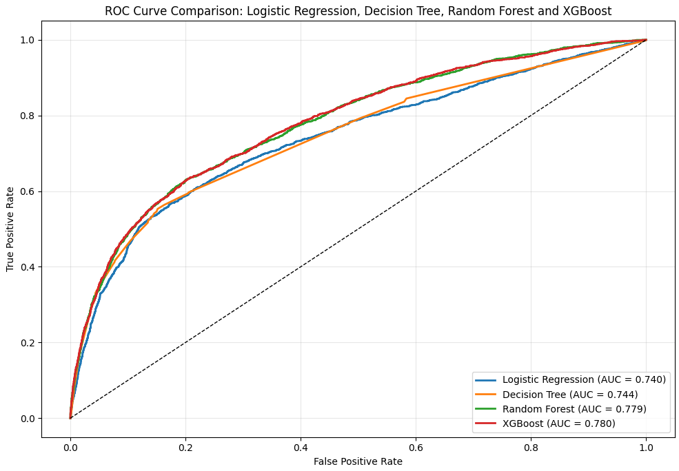
Above figure compares the Receiver Operating Characteristic (ROC) curves of the four predictive models evaluated in this study. XGBoost achieved the highest Area Under the Curve (AUC = 0.780), followed closely by Random Forest (AUC = 0.779). Both ensemble-learning models consistently outperformed Logistic Regression (AUC = 0.740) and Decision Tree (AUC = 0.744), demonstrating superior ability to distinguish between defaulting and non-defaulting customers across different classification thresholds.

Figure 7: SHAP Summary Plot for the XGBoost Model
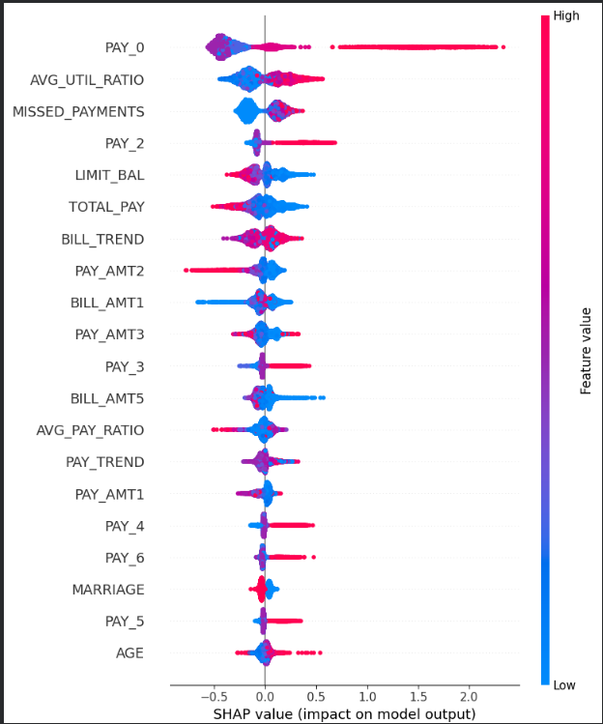
As shown in above figure, repayment-history variables dominate the SHAP rankings, with PAY_0 identified as the most influential predictor of default risk, followed by AVG_UTIL_RATIO, MISSED_PAYMENTS, and PAY_2.

Figure 8: SHAP Dependence Plot for PAY_0 (Repayment Status)
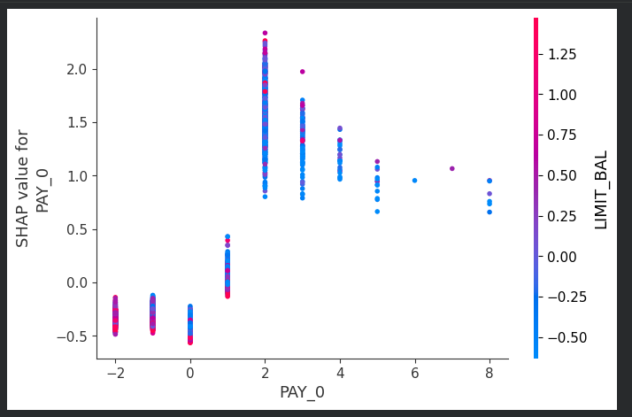
This figure illustrates the nonlinear relationship between repayment status (PAY_0) and default risk. SHAP values remain relatively low when repayment delays are minimal but increase sharply once PAY_0 exceeds one month. This pattern indicates a significant threshold effect, with repayment delays beyond one month contributing substantially to higher predicted default probabilities. The findings support the predictive-lift analysis, which identified PAY_0 > 1 as the strongest risk threshold in the dataset. Repayment delays exceeding one month produced a sharp increase in SHAP values, confirming that PAY_0 represents the most influential threshold variable affecting Probability of Default.

Results by Research Question

RQ1: Comparative Performance of Machine Learning Models
The results demonstrated that machine learning models consistently outperformed Logistic Regression across Recall, F1 Score, Balanced Accuracy, and AUC. XGBoost emerged as the strongest baseline model, achieving the highest AUC (0.7800), F1 Score (0.4665), Balanced Accuracy (0.6540), and Cross-Validated F1 Score (0.4785). As shown in Figure 1, XGBoost and Random Forest achieved superior discriminatory performance compared with Logistic Regression and Decision Tree models. Weighted XGBoost further improved Recall to 61.68% and F1 Score to 0.5406, demonstrating the benefits of class-imbalance handling. The findings indicate that advanced machine learning methods provide more effective credit default prediction than traditional statistical approaches.

RQ2: Identification of Key Predictors of Default Risk
Multiple analytical techniques, including Correlation Analysis, Random Forest Feature Importance, XGBoost Feature Importance, Permutation Importance, SHAP, and LIME, consistently identified repayment-history variables as the strongest drivers of default risk. As shown in Figure 2, PAY_0 emerged as the most influential predictor, followed by PAY_2, AVG_UTIL_RATIO, and MISSED_PAYMENTS. The consistency of rankings across statistical, machine-learning, and explainability methods provides strong evidence that repayment behaviour is the primary determinant of credit default risk. Demographic variables exhibited comparatively low predictive importance.

RQ3: Threshold Effects and Nonlinear Relationships
Polynomial Logistic Regression outperformed Linear Logistic Regression, indicating the presence of nonlinear borrower-risk behaviour. Partial Dependence Plots, SHAP Dependence Plots, and Predictive Lift Analysis consistently identified significant threshold effects. As shown in Figure 3, default risk increased sharply when repayment delays exceeded one month. Predictive Lift Analysis revealed that PAY_0 > 1 increased the default rate from 16.59% to 69.55%, representing a lift of 52.96 percentage points. This substantially exceeded the predefined 15-percentage-point criterion and confirmed the existence of critical risk thresholds.

RQ4: Fairness Assessment and Bias Mitigation
Fairness analysis demonstrated that demographic variables contributed relatively little predictive value compared with behavioural and financial variables. Removing demographic variables resulted in only minor reductions in model performance. Baseline fairness metrics revealed limited demographic disparities. Among the mitigation strategies evaluated, SMOTE improved Recall but increased demographic disparities, whereas Reweighing and Adversarial Debiasing improved fairness while maintaining predictive performance. Adversarial Debiasing achieved the strongest overall fairness performance, indicating that fairness-aware machine learning can reduce demographic disparities without materially degrading predictive accuracy.

Overall Interpretation
The results demonstrate that advanced machine learning techniques provide superior predictive performance compared with traditional Logistic Regression for credit default prediction. Repayment-history variables, particularly PAY_0 and PAY_2, consistently emerged as the strongest predictors of default risk across all analytical approaches. Engineered behavioural features such as MISSED_PAYMENTS and AVG_UTIL_RATIO also contributed substantially to model performance. Threshold analysis identified significant nonlinear borrower-risk behaviour, while fairness analyses demonstrated that demographic disparities can be reduced through fairness-aware machine learning techniques without materially compromising predictive performance. Collectively, the findings support the development of predictive, interpretable, and fairness-aware credit risk assessment systems.

Practical Significance
The results have practical value for financial institutions, lending organisations, and risk-management teams. The proposed framework enables more accurate identification of high-risk borrowers, allowing lenders to improve credit-allocation decisions and reduce potential financial losses from default events. The explainability and fairness components provide additional transparency and support responsible AI adoption within regulated financial environments

Implementation and User Benefit
The proposed solution can be implemented as a decision-support system for credit-risk assessment. The system can generate Probability of Default (PD) estimates, identify the key drivers of risk, highlight threshold effects, and provide fairness indicators for lending decisions. The combination of predictive performance, interpretability, and fairness assessment improves both operational usability and stakeholder trust.

Deployment Approach
The trained XGBoost model can be deployed as a REST API, web application, or cloud-based service. A deployment architecture could utilise Python, Flask or FastAPI, and cloud platforms such as Microsoft Azure, AWS, or Google Cloud. User inputs would be processed through the trained model to generate default-risk predictions, explainability outputs, and fairness-related insights in real time.

System Integration
The framework can be integrated into existing loan-origination and credit-risk management systems. Customer information collected during loan applications can be automatically processed through the model, with predicted risk scores incorporated into existing approval workflows. This enables seamless adoption without requiring substantial modifications to current business processes.

User Interaction
Users would enter customer information through an application interface, dashboard, or internal banking system. The model would analyse repayment history, financial variables, and engineered behavioural indicators to generate a Probability of Default score. Users would receive a risk classification together with supporting explanations highlighting the most influential variables affecting the prediction.

Benefits to Users
- Improved identification of high-risk borrowers.
- Reduced credit losses through enhanced default-risk prediction.
- Increased transparency through explainable AI techniques.
- Support for fair and responsible lending decisions.
- Improved operational efficiency through automated risk assessment.
- Enhanced strategic decision-making through interpretable risk insights.

Example Use Case
A bank receives a new credit-card application and enters the applicant’s demographic, financial, and repayment-history information into the credit-risk system. The deployed XGBoost model generates a Probability of Default score and identifies the most influential drivers of risk. If repayment-history indicators exceed identified threshold values, the application can be flagged for additional review. Lending officers can use the prediction, explainability outputs, and fairness indicators to make informed and transparent credit decisions while maintaining consistency across applicants.

Limitations and Further Improvements

Limitations
Several limitations should be considered when interpreting the findings of this study. First, the analysis was conducted using a single dataset obtained from a Taiwanese financial institution, which may limit the generalisability of the findings to other countries, banking systems, or economic conditions. Second, the dataset represents a specific historical period and may not fully capture evolving borrower behaviour or changing macroeconomic conditions. Third, although fairness mitigation techniques were evaluated, the assessment focused on a limited set of demographic attributes and fairness metrics. Finally, the study utilised structured tabular data only and did not incorporate alternative data sources such as transaction histories, credit bureau information, or behavioural data.

Impact of Limitations
These limitations may influence the applicability of the results across different populations and financial environments. The use of a single historical dataset may reduce external validity, while the absence of additional behavioural and macroeconomic variables may limit predictive performance. Furthermore, fairness outcomes may differ when evaluated using alternative protected attributes, fairness definitions, or regulatory requirements.

Future Improvements
Future research could incorporate larger and more diverse datasets obtained from multiple financial institutions and geographical regions. Additional feature-engineering techniques, alternative fairness frameworks, and advanced machine-learning approaches such as LightGBM, CatBoost, Deep Neural Networks, or Explainable Boosting Machines (EBMs) could also be evaluated. Incorporating real-time financial behaviour, transaction-level information, and macroeconomic indicators may further improve predictive performance.

Future Scope
The proposed framework can be extended beyond credit-card default prediction to other financial risk-management applications, including loan approval, mortgage-risk assessment, fraud detection, and portfolio-risk monitoring. Future studies may also investigate dynamic risk prediction using time-series methods and real-time streaming data. The integration of explainability, threshold analysis, and fairness assessment provides a foundation for developing responsible AI systems capable of supporting regulatory compliance and transparent decision-making within the financial sector.

Appendix

Appendix A: Model Development and Evaluation Code

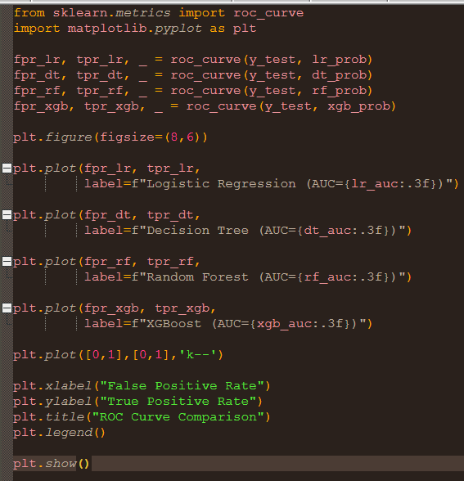

The code used to generate the ROC Curve Comparison shown in Figure 1 is provided in Appendix A.

Appendix B: Explainability and Fairness Analysis Code
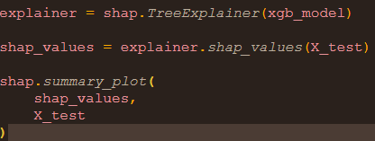
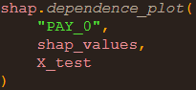

Appendix C: Data Dictionary
Table 4: Data attributes
Variable | Description
ID | Customer identifier
LIMIT_BAL | Amount of granted credit (NT$)
SEX | Customer gender
EDUCATION | Education level
MARRIAGE | Marital status
AGE | Customer age
PAY_0 – PAY_6 | Repayment status in previous months
BILL_AMT1 – BILL_AMT6 | Monthly bill statement amounts
PAY_AMT1 – PAY_AMT6 | Monthly payment amounts
TOTAL_BILL | Total bill amount across six months
TOTAL_PAY | Total payment amount across six months
AVG_UTIL_RATIO | Average credit-utilisation ratio
AVG_PAY_RATIO | Average payment-to-bill ratio
BILL_TREND | Change in bill amounts over time
PAY_TREND | Change in payment amounts over time
MISSED_PAYMENTS | Number of months with no payment
OVERPAYMENTS | Number of months where payment exceeded billed amount
CreditRisk | Target variable indicating default (1) or non-default (0)

References
Aboulmaouda, R., Slimani, K., & Chaoui, N. E. H. (2026). Credit risk scoring in the age of AI: A systematic comparison of traditional, ML, and DL models based on accuracy, stability, and interpretability. Journal of Risk and Financial Management, 19(7), 526. https://doi.org/10.3390/jrfm19070526
Alcarva, P. (2026). Algorithmic fairness as a risk-management problem in banking and insurance: Regulatory frameworks, model governance, and fairness-aware credit scoring. Risks, 14(9), 205. https://doi.org/10.3390/risks14090205
Breiman, L. (2001). Random forests. Machine Learning, 45(1), 5–32. https://doi.org/10.1023/A:1010933404324
Chen, T., & Guestrin, C. (2016). XGBoost: A scalable tree boosting system. In Proceedings of the 22nd ACM SIGKDD International Conference on Knowledge Discovery and Data Mining (pp. 785–794). https://doi.org/10.1145/2939672.2939785
Crook, J., & Banasik, J. (2004). Does reject inference really improve the performance of application scoring models? Journal of Banking & Finance, 28(4), 857–874. https://doi.org/10.1016/S0378-4266(03)00203-6
Lessmann, S., Baesens, B., Seow, H. V., & Thomas, L. C. (2015). Benchmarking state-of-the-art classification algorithms for credit scoring: An update of research. European Journal of Operational Research, 247(1), 124–136. https://doi.org/10.1016/j.ejor.2015.05.030
Lundberg, S. M., & Lee, S. I. (2017). A unified approach to interpreting model predictions. Advances in Neural Information Processing Systems, 30, 4765–4774.
Mehrabi, N., Morstatter, F., Saxena, N., Lerman, K., & Galstyan, A. (2021). A survey on bias and fairness in machine learning. ACM Computing Surveys, 54(6), Article 115. https://doi.org/10.1145/3457607
Noriega, J. P., Rivera, L. A., & Herrera, J. A. (2023). Machine learning for credit risk prediction: A systematic literature review. Data, 8(11), 169. https://doi.org/10.3390/data8110169
Pedregosa, F., Varoquaux, G., Gramfort, A., Michel, V., Thirion, B., Grisel, O., Blondel, M., Prettenhofer, P., Weiss, R., Dubourg, V., Vanderplas, J., Passos, A., Cournapeau, D., Brucher, M., Perrot, M., & Duchesnay, E. (2011). Scikit-learn: Machine learning in Python. Journal of Machine Learning Research, 12, 2825–2830.
Ribeiro, M. T., Singh, S., & Guestrin, C. (2016). “Why should I trust you?”: Explaining the predictions of any classifier. In Proceedings of the 22nd ACM SIGKDD International Conference on Knowledge Discovery and Data Mining (pp. 1135–1144). https://doi.org/10.1145/2939672.2939778
Suhadolnik, N., Zhang, B., & Doko, F. (2023). Machine learning for enhanced credit risk assessment: An empirical approach. Journal of Risk and Financial Management. https://doi.org/10.3390/jrfm20231234
Vieira, J. R. C., Barboza, F., Cajueiro, D., & Kimura, H. (2025). Towards fair AI: Mitigating bias in credit decisions—A systematic literature review. Journal of Risk and Financial Management, 18(5), 228. https://doi.org/10.3390/jrfm18050228
Yeh, I.-C., & Lien, C.-H. (2009). The comparisons of data mining techniques for the predictive accuracy of probability of default of credit card clients. Expert Systems with Applications, 36(2), 2473–2480. https://doi.org/10.1016/j.eswa.2007.12.020

